1. **Login Page**

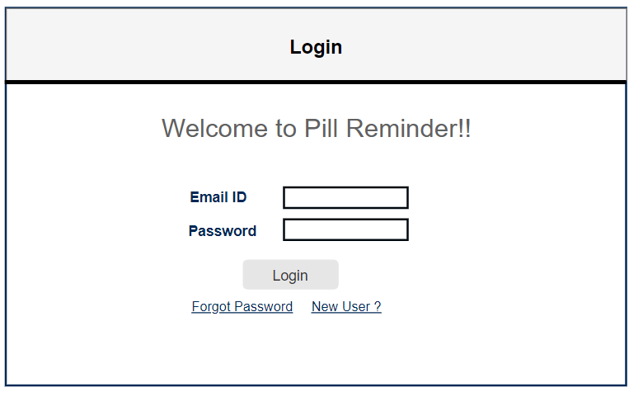

1. **Reset Password**

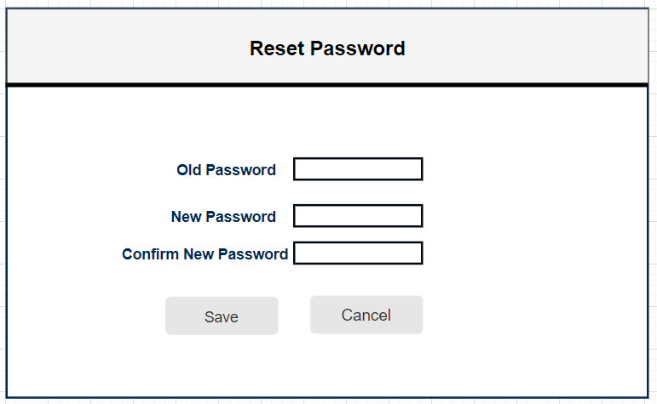

1. **Registration Page**

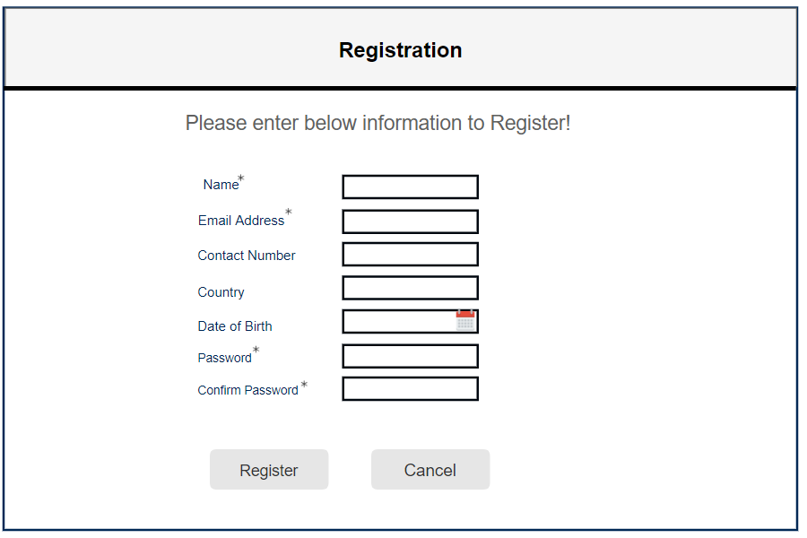

1. **Home Page:** Landing Page when the user registers and has not added medical records in the system.

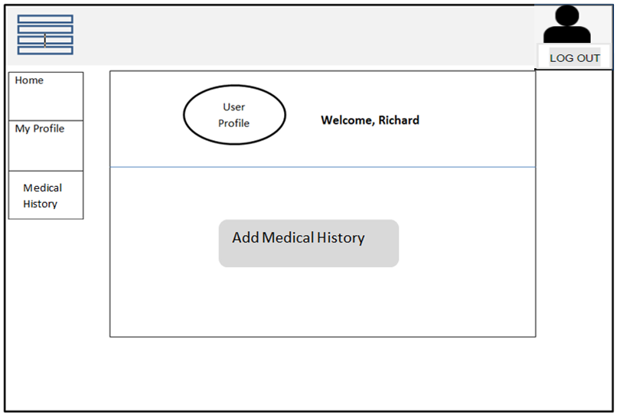

1. **Home Page:** Landing Page when the user has added medical records in the system and pills are scheduled for the user or his/her dependents.

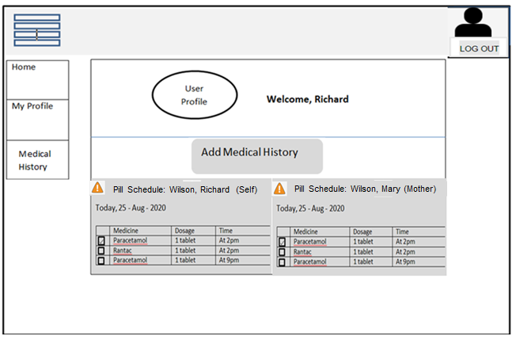

1. **My Profile Page:** Profile information of the logged in user.
   * When user clicks on ‘My Profile’ option from Menu, the respective option will be highlighted and user will be navigated to the My Profile page.

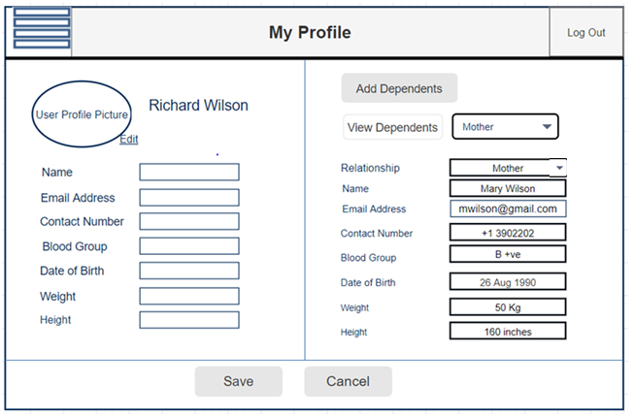

1. **Medical History:** Page to view your/dependents medical history.
   * When user clicks on ‘Medical History’ option from Menu, the respective option will be highlighted and user will be navigated to the ‘Medical History’ page.

* In below screen, the user has clicked on Add Medical History button to add a new row in the table.

